|  |
| --- |
| NDSU SD1319 |
| No Touch Bird Call Display Owner’s Manual |
| Last Revised 5/10/14 |

***How to turn on/off the Bird Call Display:***

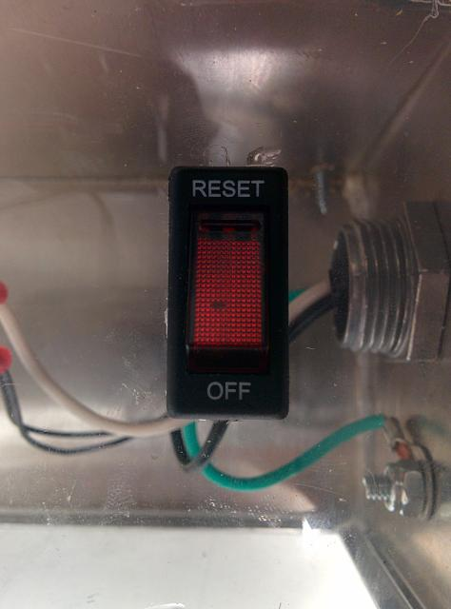Plug the electrical cord into a standard wall outlet. There is a circuit breaker on the inside of the enclosure. Turn the circuit breaker to **Reset** if it is in the Off position. The display should now be on and the LED on the PCB should be lit up.

To turn off the display, either unplug the cord from the outlet or turn the breaker to the Off position.

Circuit Breaker

***How to convert audio files to ad4 format:***

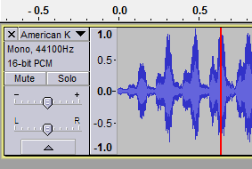

Obtain or record an audio file (bird call) in either WAV or MP3 formats. If the audio file is not in either of these two formats, convert the audio file by using the freeware program called Audacity. Audacity can be found online at http://audacity.sourceforge.net/.

High volume audio file

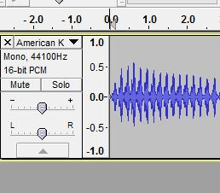

Playable low volume audio file

If the audio file is high volume, you will need to lower the amplitude of the sound using Audacity or similar program in order for the audio playback chip to function correctly.

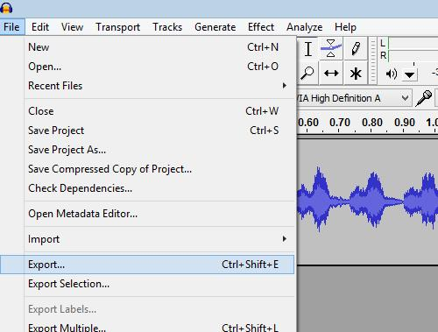

Save the edited file as a WAV file by going to **File,** **Export…**, giving the file a File Name, and choosing Save as type: WAV (Microsoft) signed 16 bit PCM in the dropdown box. Then, click **Save**.

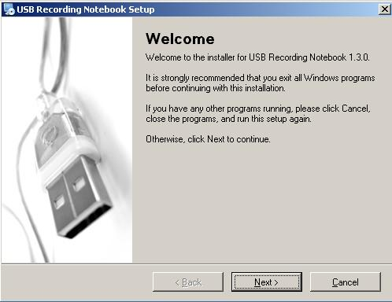

There are only a couple options for converting an audio file into the AD4 format. The best option is to use the free software titled USB Recording Notebook 1.3.0. It can be found for free at <https://docs.google.com/file/d/0B4p82-pNB6o7OHlmdDA0dk1QVm8/edit>. Extract and open the software once downloaded. Install the software by following the prompt.

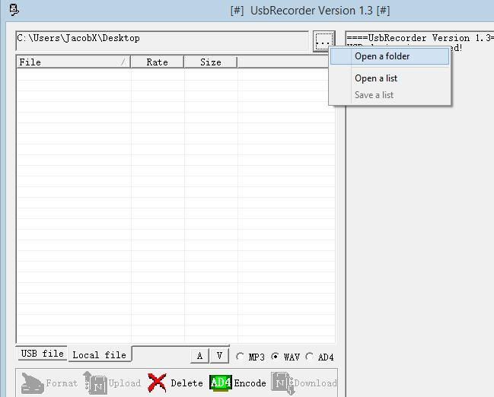Open up the software you just installed. Browse for the folder where your audio files are stored by clicking on **Open a folder**

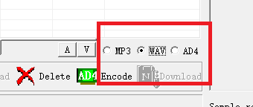Depending on what type of audio files you have, you will need to select the appropriate radio button (MP3 or WAV) before your audio files will be listed.

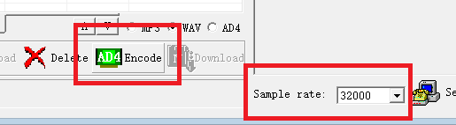

Set the sample rate to 32000. Select all the files you want to encode to the AD4 format and click the **Encode** button. The AD4 files will be saved to the same folder as the files you are converting. You will now need to properly name the AD4 files.

***How to name the AD4 files:***

The audio player reads files stored on the SD card based on addresses, which correspond to what file name you specify for the file. Below is a table showing the relation between file names and addresses. The first file to be played will be the one named 0000.ad4, the second being 0001.ad4. 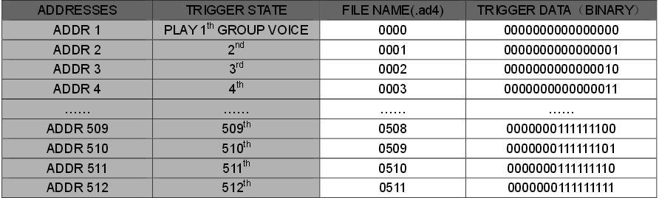

The audio player has the capability of playing up to 512 songs.

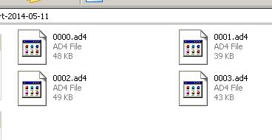

Properly named audio files

***How to format the micro SD card:***

In order for the audio playback chip to read AD4 files from the SD card, it needs to be formatted to the FAT16 standard. In My Computer, locate your SD card connected to your computer and right click on it. Click on **Format** in the list.

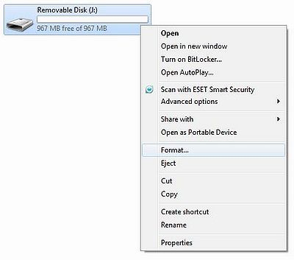

The Windows formatting utility will pop up. The file system that needs to be chosen is FAT. The allocation size can be left at the default. The volume label does not matter. Click **Quick Format**, then click **Start** and the formatting should finish in a couple seconds.

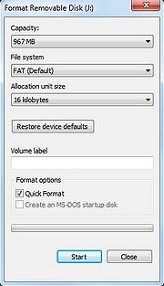

The micro SD card is now properly formatted. It is possible to put on properly named AD4 files onto the card now.

***How to change the display (poster):***

The bird call display allows for the poster that is between the clear acrylic front and the metal enclosure to be replaced. There are 8 screws on the front of the display that can be removed with a screwdriver that will allow for the acrylic and poster to be removed from the enclosure. To put a new poster into the display, the dimensions need to be 30 inches long and 16.75 inches wide. A printing shop such as the NDSU Graphic Services will be able to print the new poster that was created. After the poster is printed to the correct dimensions, the poster needs to be taped on top of the enclosure and aligned with the sides of the enclosure. Open up the back of the enclosure by removing the 8 screws and 2 back plates. This will give access to the interior of the enclosure where you will need to trace the hole outlines onto the poster. After all the sensor hole outlines are sketched on the poster, the poster can be removed and the outlines that were traced on the poster need to be cut out with an X-Acto knife. After all the holes are cut out of the poster, it can be put back onto the enclosure and taped down after aligning the poster with the sensor holes. The enclosure can now be put back together by screwing back on the acrylic front and the 2 back pieces.

Current display

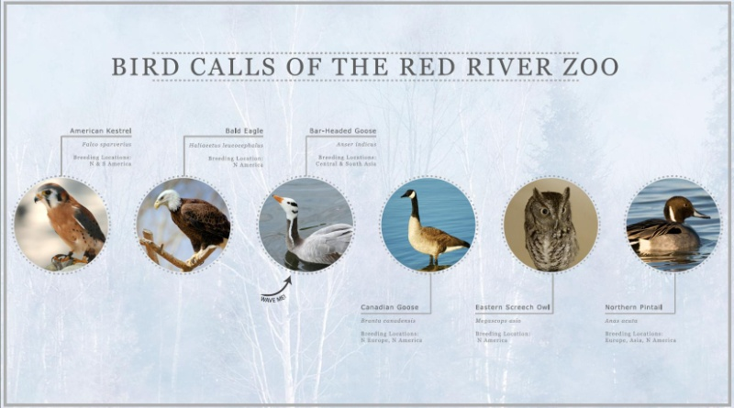

The InDesign file of the current poster included in the documentation can be edited to change out the current birds with new ones. It can also be used as a template for a completely new use of the display in conjunction with new audio files on the SD card.